Restorative Circle
Community Participant Guide
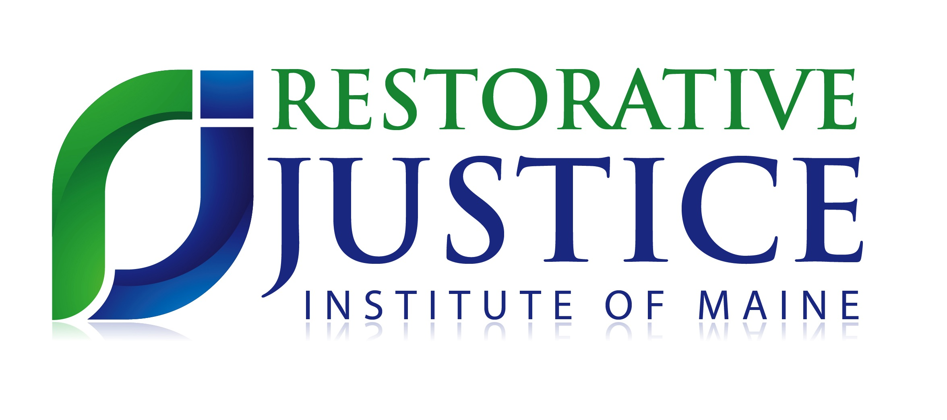
www.rjimaine.org

Dear Community Member,

We would like to invite you to take part in an important opportunity that is available in your community. The Restorative Justice Institute of Maine, with our local Community Justice Collaborative advisory group, __________________(name of CJC) is seeking interested individuals to get involved in local restorative justice circles.

Restorative Justice is a process that can be used when harm has occurred. It brings together those who have caused harm with those who have been affected by those actions so that meaningful steps can be taken to repair any harm done to an individual or community. Restorative Justice offers a way of addressing our need for connections by increasing understanding, building and repairing relationships and connections to community. It addresses wrongdoing in a way that maintains dignity and accountability. It builds a community that does not stigmatize or marginalize wrongdoers but offers a way for them to understand how their behavior has impacted others, while creating a path to move forward.

As a community member, you can be a very important part of this process. We are developing a roster of dedicated Community Participants to bring a perspective from the broader community to circles. People are not always able to see the full scope of their actions. Community Participants bring a wider perspective to a personal matter. This role helps those who have caused harm understand that they are valued by the community and that their actions, both harmful and helpful, have a ripple effect in their community. It is also an opportunity for you to contribute ideas and resources you may have that could be helpful in resolving the matter. This understanding leads to a greater level of accountability and a feeling of being more connected to, and supported by, the community.

In order to become a Community Participant, you will need to send a brief letter of interest to the RJIM Program Coordinator, who will connect you with a staff for a brief orientation so that you can be prepared to take part in a meaningful way in circle with others. The commitment of a Community Participant is flexible, and involves learning about the circle process itself, taking part in a meeting with a facilitator prior to any circle you attend, and being prepared to share your thoughts in a focused and restorative manner while in circle.

If you are interested in becoming a Community Participant, please read the attached Orientation & Training Guide and contact RJIM’s Program Coordinator to become a part of our local Community Participant roster. You will then be called upon as opportunities arise for upcoming circle participation in your area.

We thank you for your interest in becoming involved as a Community Participant and look forward to connecting!

-The RJIM Team

Community Participant Orientation

and Training Guide
Table of Contents
RJIM’s Restorative programming for youth 4
Role of community participant 5
Who might be a community participant 6
Guidelines and expectations of community participants 7
Confidentiality and boundaries 8
Participating in accountability circles 9
How to participate in the repair agreement 11
Staying aware in the circle 12
Notes on adolescent development 13
Pre-Circle Checklist 14
Information Packet for Prospective Community Participants 15
Process for becoming a community participant 16
Letter to Prospective Community participants 17
What is restorative justice? 18
Template for letter of interest 19

RJIM’s Restorative Programming for Youth

The restorative justice circles are facilitated by trained local facilitators from the Restorative Justice Institute of Maine (RJIM).. Across the State, RJIM works with a network of local, multidisciplinary advisory groups called “Community Justice Collaboratives” to offer an array of restorative circle processes to youth who have committed an act of wrongdoing that is a “chargeable offense.” These restorative processes can be offered at schools or community programs as a preventative measure, as a diversion from court or confinement, or as a reintegration effort when a youth has been removed from their community due to confinement, residential needs, or suspension or expulsion from school.

Program Eligibility: Typically, RJIM works with youth under the age of 18 who have committed an act of wrongdoing that involves breaking the law. Referrals primarily come from juvenile probation officers, school resource officers and court, but can be made by anyone. This is a voluntary process for all parties. Each person who participates in a restorative process makes an informed decision to participate.

The Process from Referral to Completion:
- A referral is made
- Facilitator meets with the family and youth to complete intake paperwork and learn more about the program.
- At this same meeting, the facilitator introduces the 5 Restorative Questions that will be asked during the circle, and the family has a chance to answer them. This prepares them for the meeting, while giving the facilitator an idea of what to epect in the circle.
- Victims, supporters, and community members also meet with facilitators individually to understand and prepare for the restorative process.
- The circle is held with all willing parties. Sometimes the victim will participate through a proxy, or a surrogate victim.
- Restorative processes result in a written plan which consists of action items that will be done by the youth and others to repair the harm that was done and to help build connection in the community.
- Typically, these plans take about 2-3 months to complete, depending on the incident and the items on the plan.
- Once the plan is completed, a closing circle is held to review the plan and celebrate successes!

Role of Community Participant
The role of the Community Participant is to bring perspective about how the community has been impacted by the harmer’s actions if applicable or to provide a broader view of community so that the harmer understands that actions do have impact even when people are not directly affected. There are different ways a CP may interact with a circle depending on whether or not they have been impacted by the ripple effect of the incident. Community Participants may:
- Offer a unique perspective as a community member
- Bring a resource that may be needed
- Experience a circle as part of the training protocol to become a Restorative Justice Facilitator

While the Community Participant perspective is one key factor to the success of a circle, there are limits to the role:

- A Community Participant does not offer personal advice to the harmer or their support people
- A Community Participant does not offer personal advice to those who have been impacted by the harm or their support people
- It is important for the Community Participant to be sensitive to the needs of the harmer and harmed at all times.
- A Community Participant’s role is generally limited to participation in the circle. See Confidentiality and Boundaries for guidelines.
- In order to ensure that the focus remains on the incident that caused harm, the Community Participant will not be asked the same in depth questions as others in the circle.
- As a Community Participant, it is necessary to allow the facilitators to guide how you will interact with the group.

Who Might be a Community Participant

- Community Participants are people who are interested in and have become familiar with restorative justice.

- Community Participants need to have good judgment and are aligned and oriented to the restorative process.

- Community Participants can also be a person who may not be directly related to an incident, but offering an experience or perspective that can add meaning to the process

- Community Participants are often people who are from the community that the incident happened in.

- Community Participants are often people who bring an awareness of local resources and local community perspective and culture.

- Candidates for a Community Participant would be: Teachers, Business Owners, Local Government Representative, Former RJ Participants, Members of the Faith Community, Concerned and Involved Citizens.

Guidelines & Expectations

for Community Participants
It is very important that, as a Community Participants, you are clear about your role. There are specific roles and therefore guidelines for how to participate in a circle. These guidelines both protect the process and help make space for Community Participants to fully contribute to the circle.

- The Community Participant will meet with the facilitator prior to the circle to prepare for their role.
- The Community Participant should come to the circle grounded in the restorative framework (see “What Is Restorative Justice) and with a clear understanding of the incident.
- CPs may bring ideas about how the incident might have impacted the community. (Example: “As a community member, when I hear about theft in my community, I wonder about the safety of my belongings in my own home, and that’s scary.”
- When Community Participants speak, they should be connecting it back to why they are there. This means that they are thinking about community perspective, resources, and relationships. (Example: “I noticed you said you enjoy riding bikes, and I know of a bike shop that may be looking for mechanics to train” or “From where I sit, it seems like you and your mom had a great relationship before this incident- it’s kind of sad to hear about the ways it’s changed as a result”)
- CP’s may also point to needs they noticed coming up in the circle that are not being addressed in the plan and inquire whether the group would like to address them. (Example: “I remember back when we were talking about who has been impacted, you mentioned your football coach and team- but we have not talked about that in the plan and I think we should.”)
- While the CPs play an important role in the restorative process, it is critical that CPs recognize that much of the restorative conversation takes place between the parties who have been directly affected by the incident. CPs can count on the facilitator to ask meaningful questions of them at the most appropriate time during the conversation.

Confidentiality and Boundaries
RJIM takes confidentiality very seriously and facilitator activities reflect the organization’s commitment to protecting participant information. It is expected that all participants will not share anything that is said or done during any part of the process with anyone who is not participating in this Restorative Process. This is true of Community participants, who are acting as volunteers for RJIM.

It is not the role of RJI Community Participants to have relationships with youth outside the circle, as RJI does not do background checks or provide adequate support for these relationships to be part of the role. The Circle Participant role is only in the circle itself.

It is understood, however, that there may be circumstances where a connection is made and a family and youth choose to continue a relationship with the person who was a community participant whom they met in the circle. If this occurs, the following should be taken into account
  - Inform the facilitator of this continued relationship so they can in turn inform their supervisor.
  - While the informed consent contains a statement about the boundaries of RJI’s involvement, it is still important to clarify verbally with the family a reminder that the continued relationship is their choice completely, and is not part of RJI’s Community Participant programming.

Participating in Accountability Circles
This can be a very intense, but meaningful process. As a Community Participant, you understand the far-reaching effects connecting with other individuals in the community can have. While in circle, you can expect to have a great many thoughts and strong feelings about how to help the situation that is being discussed and beyond. It is normal to experience a surge of excitement or emotion when you see the impact this process can have on individuals and the community.

It is important to stay focused on the matter or incident for which everyone was brought together. Preparing your thoughts ahead of time, once you know the details of the situation, will help your participation be meaningful and pertinent.However, CP participation works best when you spend a lot of time in the circle listening and suspending assumptions. This will allow for responses that are grounded in the details that unfold during the circle.

Although it can be intense, it is a very structured process run by trained facilitators. For the first part of the process, all participants are asked to respond to specific restorative questions in a particular order.

For the person who has caused the harm:
- What happened?
- What were you thinking about at the time?
- What have you thought about since?
- Who did your behavior impact?
- What do you need to make it right?

For those who have been impacted:
- What did you think when you realized what happened?
- How do you feel about what happened now?
- How did this impact you?
- What do think are the main issues?

(continued on pg 10…)
For Community Participants:
Facilitators will ask the Community Participant questions based on their connection to the incident.

If you are less connected to the incident as a community participant, you may be asked a simple question, like:

- Is there anything else that you would like to add?
- As you were listening what themes came up for you?

If you are a community participant who has been impacted by the ripple effect of the incident, you may be asked questions such as:

- As a < name the CP’s function> can you tell us what you thought when you heard what had happened?
- From your perspective, what impact has this incident had on the community ?
- As you were listening what themes came up for you?

The facilitator will work with you ahead of time to prepare you for the circle and will talk with you about your role and the specific questions that you will be asked.

How to participate in the repair agreement
Restorative processes focus on harms, needs, and obligations. The circle conversation begins by discussing harms. Participants are asked what happened and how they were impacted. As the conversation continues, needs emerge. When the circle gets to the repair agreement planning phase, the plan focuses on “obligations,” or the things that have to happen to repair the harm that has been done. Input is sought from everyone in the circle. There is still a structure in place but the process is a bit less formal.

The Community Participant’s role in this phase of the circle will vary based on how connected they were to the incident and the extent they wish to stay involved. The Community Participant can be most helpful by:

- Pointing out observations about things that were said in the circle that may not be being addressed in the plan phase
- Highlighting a need that has emerged from the discussion in the circle
- Contributing an idea about a resource that supports any activity identified as part of the repair agreement
- Brainstorming ideas about ways youth can repair the harm or give back to the community as part of their repair agreement.

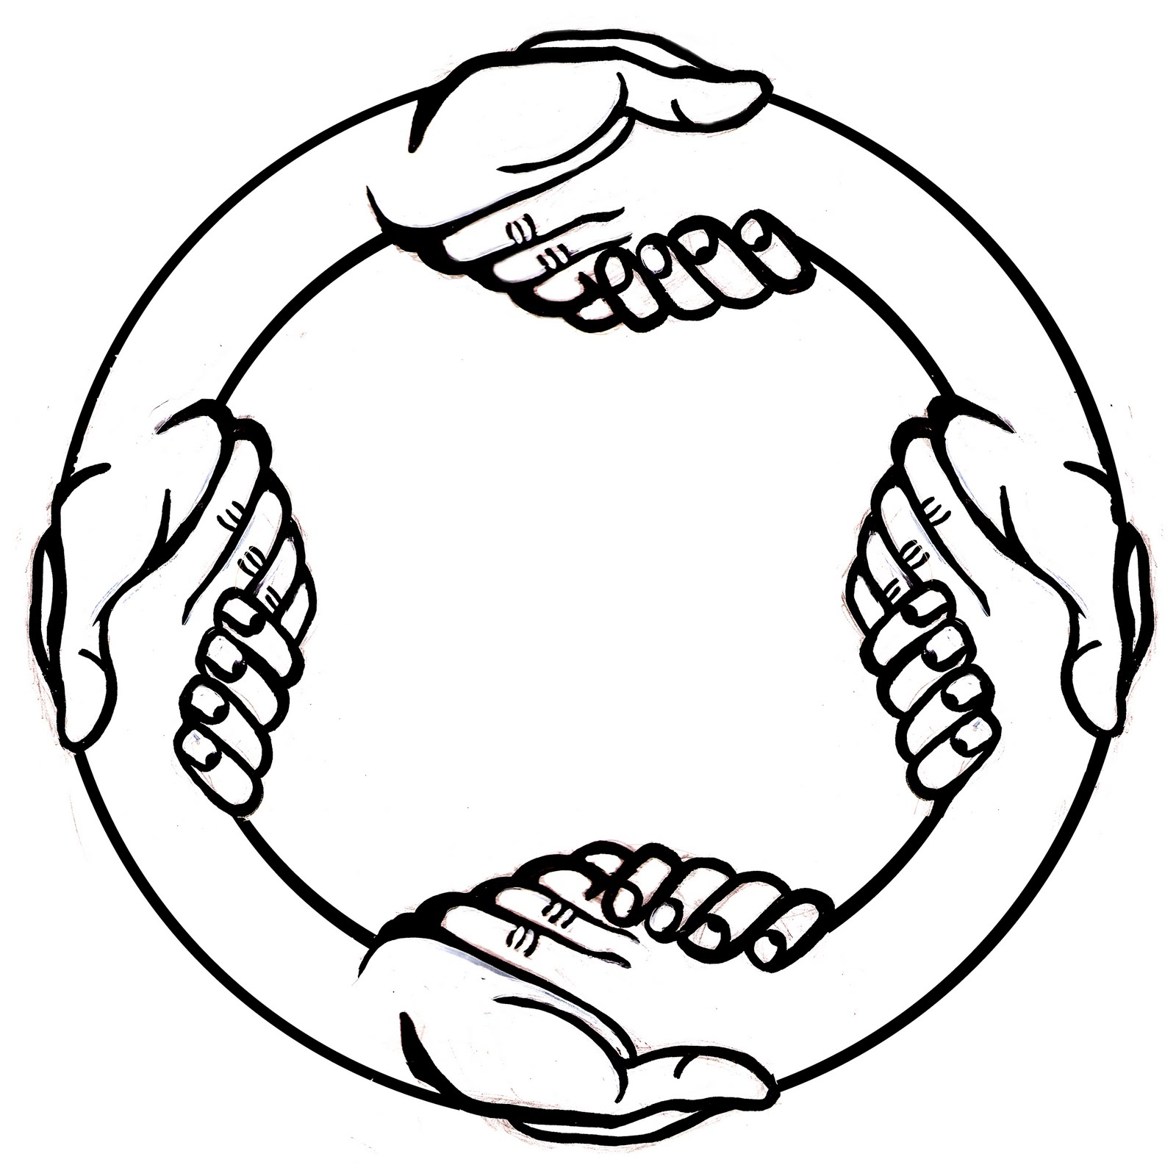

Staying Aware in Circle
Understanding the dynamics of a group and the developmental stage of who you are talking to will help you, as the CP, consider the best way to share your perspective.

Understanding the group dynamic
It is likely that those participating in a circle whether they are the person who caused the harm, the person who is a victim of the harm, or those who are there in support of either may be feeling a bit unsure of the process or anxious about the outcome. It may take some time for the circle to develop into a place where people feel OK about sharing.

Keep in mind that parents of the youth who caused harm may be hearing some difficult things or developing an understanding about their child that they did not have previous to the circle. It can be unsettling and worrisome when your child becomes involved with juvenile justice. It may also be challenging for that parent to have to face the person who was impacted by their child’s wrongdoing.

As much as possible, use dialogue that reflects the restorative process. This means:
- using “I” statements when you are talking about your view of the community impact
- referring to the details of the situation to highlight any point you want to make
- refraining from offering personal judgment about character of the offender.

Strategies for Effective Communication and Developmental Frameworks

Understanding an individuals’ ability to give and receive information is necessary when taking part in a circle as a Community Participant.
For youth in particular it is helpful to remember:
- They are moving toward a more independent way of thinking and doing things
- They are developing a sense of what is important and valued by them
- Peer relationships are significant to them

Overall, being a careful listener is one of the most important communication techniques one can use.

Some Notes on Adolescent Development
Here are some key developmental tasks of 10-17 year olds. Everyone develops these skills at different rates, so it’s good to keep in mind that certain behaviors may not be a sign of rudeness or apathy, but are rather developmentally appropriate responses to a circle experience.

Adolescents are at varying stages of developing:
- ability to understand and work with abstract concepts
- clearly work with cause and effect
- awareness of social impact, vs. self impact
- working with authority
- independence
- personal value system
- intense peer relationships
It is part of normal adolescent development if a young person
- feels misunderstood
- may disobey as a way of building independence
- is most aware of their own experience, and have strong feelings about it
- experiences strong feelings
- experiments with risk taking behavior
- experiences family conflict due to emerging independence

Pre Circle Checklist

The following checklist is to help Community Participants prepare for participating in a circle. This tool can be used once you have been trained as a Community participant and have been invite to come to a circle.

- Review the document “What Is Restorative Justice?” and ground yourself in a restorative approach

- Meet with facilitator to make sure you understand the focus of the circle you are being invited to attend

- Review “Strategies for Effective Communication”

- Clarify your thoughts about the impact behavior has on community

- Contact facilitator with any unanswered question about the situation or the circle process

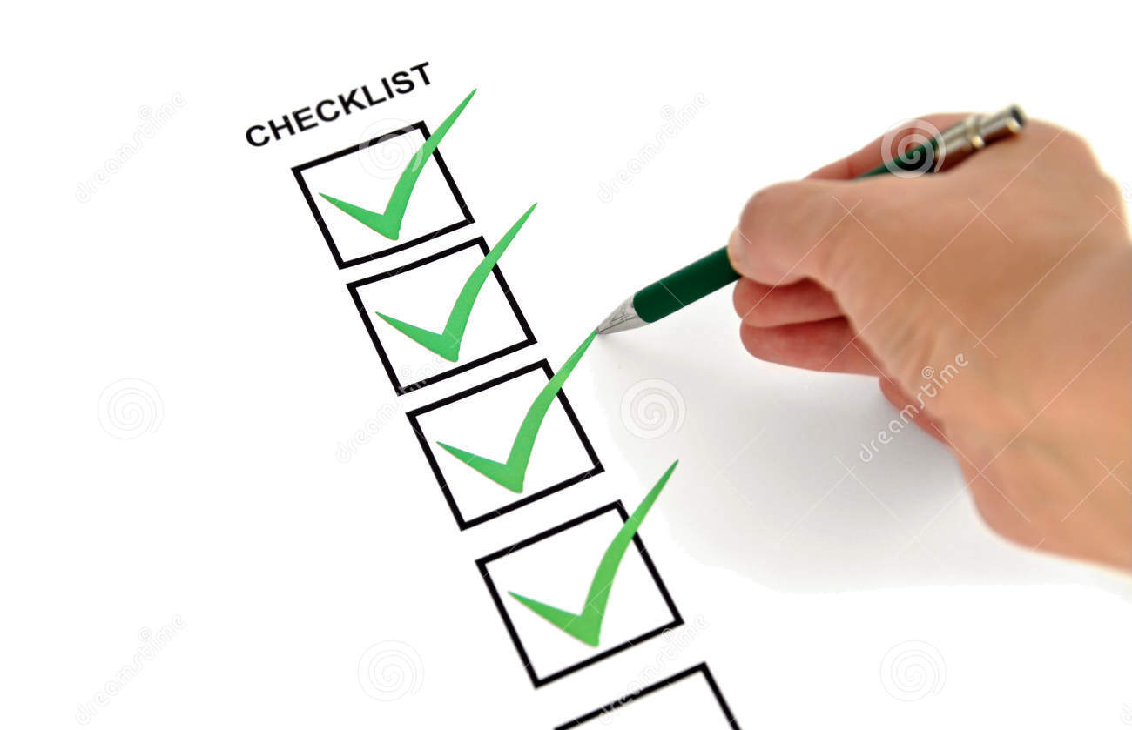

Information Packet For Prospective Community Participants

Process for Becoming a

Community Participant

- Any CJC Member or RJIM Staff may share an information packet with potentially interested Community Participants.

- The Information Packet to share includes:
  - Letter to community member
  - Process for Becoming a Community Participant
  - “What is Restorative Justice?” handout
  - Template for submitting a letter of interest.

- The interested community member then completes the letter of interest and sends it to RJIM, either via mail or email.
  - The email address is: 14 Maine St. Box 24 Brunswick, ME 04011.
  - The email is submit@rjimaine.org

- Once letter of interest is received, Community Participant candidates will be sent a training packet and will be contacted by RJIM staff within 1 week to set up an orientation.

- RJIM staff will track all engagement and training in Airtable.

- Once training and orientation are complete, community participant is added to RJIM’s roster in Airtable to be called upon as opportunities to participate arise.

Dear Community Member,

We would like to invite you to take part in an important opportunity that is available in your community. The Restorative Justice Institute of Maine, with our local Community Justice Collaborative advisory group, __________________(name of CJC) is seeking interested individuals to get involved in local restorative justice circles.

Restorative Justice is a process that can be used when harm has occurred. It brings together those who have caused harm with those who have been affected by those actions so that meaningful steps can be taken to repair any harm done to an individual or community. Restorative Justice offers a way of addressing our need for connections by increasing understanding, building and repairing relationships and connections to community. It addresses wrongdoing in a way that maintains dignity and accountability. It builds a community that does not stigmatize or marginalize wrongdoers but offers a way for them to understand how their behavior has impacted others, while creating a path to move forward.

As a community member, you can be a very important part of this process. We are developing a roster of dedicated Community Participants to bring a perspective from the broader community to circles. People are not always able to see the full scope of their actions. Community Participants bring a wider perspective to a personal matter. This role helps those who have caused harm understand that they are valued by the community and that their actions, both harmful and helpful, have a ripple effect in their community. It is also an opportunity for you to contribute ideas and resources you may have that could be helpful in resolving the matter. This understanding leads to a greater level of accountability and a feeling of being more connected to, and supported by, the community.

In order to become a Community Participant, you will need to send a brief letter of interest to the RJIM Program Coordinator, who will connect you with a staff for a brief orientation so that you can be prepared to take part in a meaningful way in circle with others. The commitment of a Community Participant is flexible, and involves learning about the circle process itself, taking part in a meeting with a facilitator prior to any circle you attend, and being prepared to share your thoughts in a focused and restorative manner while in circle.

If you are interested in becoming a Community Participant, please read the attached Orientation & Training Guide and contact RJIM’s Program Coordinator to become a part of our local Community Participant roster. You will then be called upon as opportunities arise for upcoming circle participation in your area.

We thank you for your interest in becoming involved as a Community Participant and look forward to connecting!

-The RJIM Team
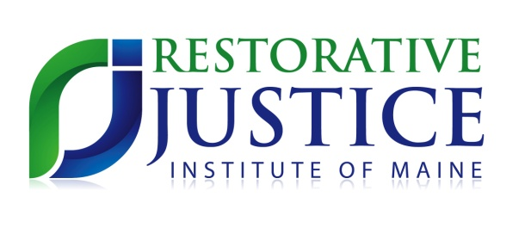
What Is Restorative Justice?

Restorative Justice is a philosophy that recognizes and acknowledges the harm caused by crime and acts of wrongdoing. Instead of focusing solely on the individual that caused the harm and how to punish this person, it focuses on the victim that was harmed, the community that was impacted and the ways in which the offender can make things right.

We are working toward Restorative Justice when we……

Focus on the harms of wrongdoing more than the rules that have been broken

Show equal concern and commitment to victims and offenders involving both in the process of justice

Work toward the restoration of victims, empowering them and responding to their needs as they see them

Support offenders while encouraging them to understand, accept and carry out their obligations

Recognize that while obligations may be difficult for offenders, they should not be intended as harms and they must be achievable

Provide opportunities for dialogue, direct or indirect, between victims and offenders as appropriate

Involve and empower the affected community through the justice process, and increase its capacity to recognize and respond to community bases of crime

Encourage collaboration and reintegration rather than coercion and isolation

Give attention to the unintended consequences of our actions and programs

Show respect to all parties including victims, offenders and justice colleagues

Community Participant Letter of Interest

Dear Restorative Justice Institute of Maine:

I would like to serve as a Community Participant in Restorative Circles. I believe I bring a useful community perspective because I am ( check all that apply)

____ a parent
____ a business owner
____ a member of the faith community
____ a member of the social service community
____ an educator
____ law enforcement
____ a person who has had contact with the judicial system
____ in local government
____a person who has participated in the Restorative Justice process in another role
____Other ( please explain)

1.) In a paragraph or two please describe why being a Community Participant is meaningful to you- what experience or knowledge do you bring to the role?

2.) In one or two sentences please describe your understanding of restorative justice. If you are not familiar with restorative justice, please describe your understanding of justice in general.

Sincerely,

_____________________________ _____________________
(signature) (date)
Name (printed) ____________________________Phone __________________ Email______________________________________________________
Ok to text? : Y N
OK to leave message? Y N

This letter can be sent to:
RJIM 14 Maine St. Box 24 Brunswick, ME 04011, or emailed to submit@rjimaine.org.

Once your letter of interest is received you will receive a training packet and be contacted by a local Restorative Justice Facilitator within one week, usually by email. Once you’ve reviewed the training packet, you will respond to that Facilitator to set up a training session and be added to the Community Participant Roster. You will then be contacted as opportunities arise. Thank you!

