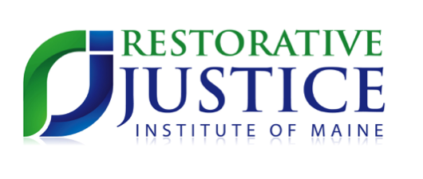

# A Heartfelt Thanks to Our Sponsors:

2018 Restorative Justice Think Tank:

Voices of Transformation

*November 2, 2018 at Bates College in Lewiston*

Welcome!

[Hours]

(xxx) yyy-yyyy

[Street Address]