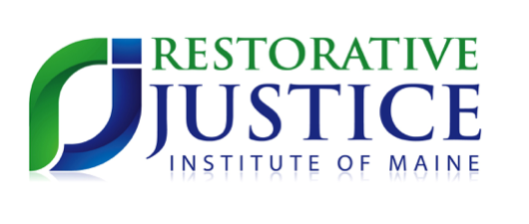

8:30 Registration (Chase Hall)

9:00 Welcoming Remarks

9:30 Intentions and Simmering Questions

10:00 Workshop Sessions I (Commons)

11:10 Break

11:20 Workshop Sessions II

12:30 Lunch & Networking (Back to Chase)

1:15 Dialogues

3:00 Closing Circles

3:30 Goodbye

2018 Restorative Justice Think Tank:

Voices of Transformation

*November 2, 2018 at Bates College in Lewiston*

Workshops